Full Name: Rakyan Satrya Adhikara

Student ID: 219548135

SIT210 Task 2.2C

Q1: Upload your video (to either YouTube, OneDrive or Deakin sites)

and include a link.

YouTube Link: <https://www.youtube.com/watch?v=H60nJU9P7kc>  
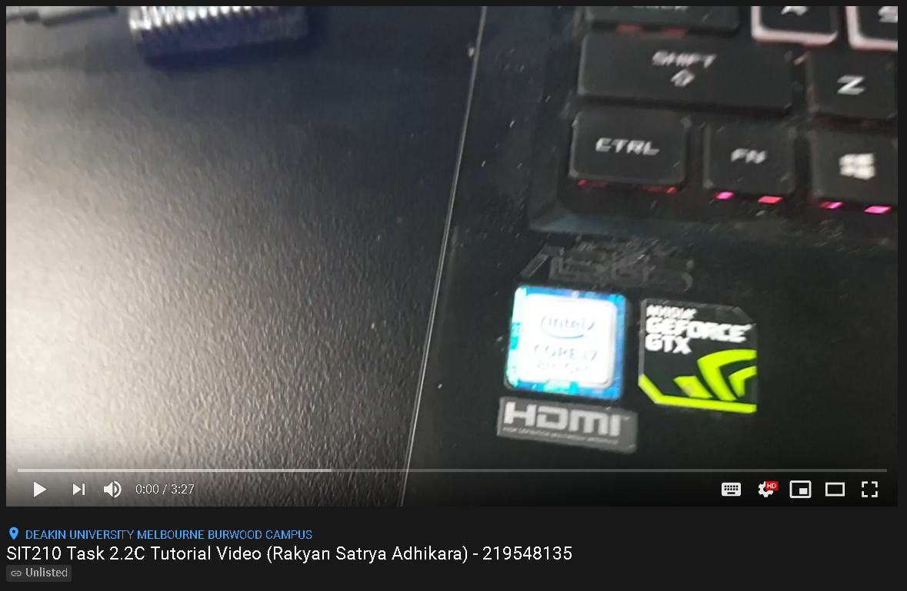

Q2: Write a short reflection note outlining your experience compared to just completing task 2.1P.

Creating tutorial is not just on how explaining the code or what are the requirements, but also on how clear it is for explaining those things in details.